

# Database Systems

# Assignment 1

**Total Marks: 100 (20 each)**

**Due Date: 4th November, 2024 11:59 on portal**

**Instructions:**

1. *This is a handwritten assignment. Submit the PDF/word file on portal.*
2. *Choice is yours. Only one student of the group needs to submit it on portal.*
3. *Late submission will cause you to lose 10% per day. After three days of deadline no submissions will be entertained.*
4. *Copied assignments will get straight ZERO.*
5. *There will be a quiz based on assignment in the very next class of the submission date.*

Q1. Composite and multivalued attributes can be nested to any number of levels. Suppose we want to design an attribute for a STUDENT entity type to keep track of previous college education. Such an attribute will have one entry for each college previously attended, and each such entry will be composed of college name, start and end dates, degree entries (degrees awarded at that college, if any), and transcript entries (courses completed at that college, if any). Each degree entry contains the degree name and the month and year the degree was awarded, and each transcript entry contains a course name, semester, year, and grade. Design an attribute to hold this information.

Q2. Design an ER schema for keeping track of information about votes taken in the U.S. House of Representatives during the current two-year congressional session. The database needs to keep track of each U.S. STATE’s Name (e.g., ‘Texas’, ‘New York’, ‘California’) and include the Region of the state (whose domain is {‘Northeast’, ‘Midwest’, ‘Southeast’, ‘Southwest’, ‘West’}). Each CONGRESS_PERSON in the House of Representatives is described by his or her Name, plus the District represented, the Start_date when the congressperson was first elected, and the political Party to which he or she belongs (whose domain is {‘Republican’, ‘Democrat’, ‘Independent’, ‘Other’}). The database keeps track of each BILL (i.e., proposed law), including the Bill_name, the Date_of_vote on the bill, whether the bill Passed_or_failed (whose domain is {‘Yes’, ‘No’}), and the Sponsor (the congressperson(s) who sponsored—that is, proposed—the bill). The database also keeps track of how each congressperson voted on each bill (domain of Vote attribute is {‘Yes’, ‘No’, ‘Abstain’, ‘Absent’}). Draw an ER schema diagram for this application. State clearly any assumptions you make.

Q3. Consider a CONFERENCE_REVIEW database in which researchers submit their research papers for consideration. Reviews by reviewers are recorded for use in the paper selection process. The database system caters primarily to reviewers who record answers to evaluation questions for each paper they review and make recommendations regarding whether to accept or reject the paper. The data requirements are summarized as follows:

* Authors of papers are uniquely identified by e-mail id. First and last names are also recorded.
* Each paper is assigned a unique identifier by the system and is described by a title, abstract, and the name of the electronic file containing the paper.
* A paper may have multiple authors, but one of the authors is designated as the contact author.
* Reviewers of papers are uniquely identified by e-mail address. Each reviewer’s first name, last name, phone number, affiliation, and topics of interest are also recorded.
* Each paper is assigned between two and four reviewers. A reviewer rates each paper assigned to him or her on a scale of 1 to 10 in four categories: technical merit, readability, originality, and relevance to the conference. Finally, each reviewer provides an overall recommendation regarding each paper.
* Each review contains two types of written comments: one to be seen by the review committee only and the other as feedback to the author(s).

Q4. Consider the ER diagram shown in following figure for part of a BANK database. Each bank can have multiple branches, and each branch can have multiple accounts and loans.

* List the strong entity types in the ER diagram.
* Is there a weak entity type? If so, give its name, partial key, and identifying relationship.
* What constraints do the partial key and the identifying relationship of the weak entity type specify in this diagram?
* List the names of all relationships.
* List concisely the user requirements that led to this ER schema design.

Justify you Choices

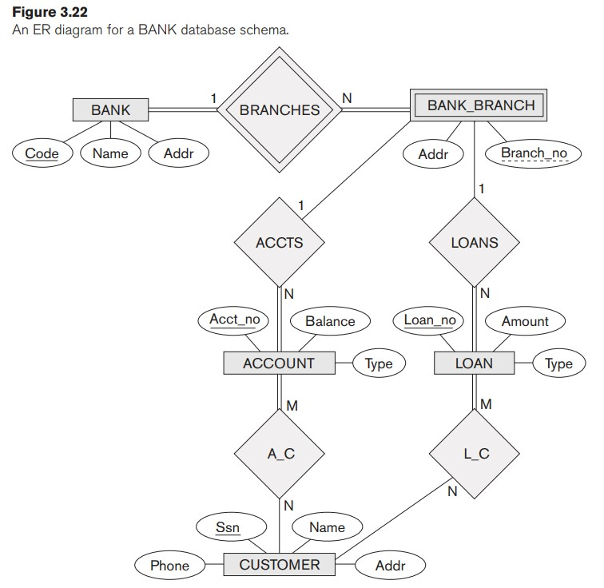

Q5. Use mapping rules to reduce the ER diagram to a relational schema. Mention Primary and Foreign keys with proper notations.



